Minimizing Min/Loss Sprint 10/21/22

Sources: <https://github.com/instance01/qubo-nn>

<https://colab.research.google.com/github/OpenJij/OpenJijTutorial/blob/master/source/en/004-DWaveOceanSDK.ipynb>

What we did this week:

1. Looked for a good example for min/loss QUBO
2. Found a great feature selection Example maybe Abraham can refer to: <https://github.com/dwave-examples/feature-selection-notebook>
3. Implemented the colab by cloning the github
4. Ran it and took over 12 minutes long
5. Saw that we need to implement D-Wave as well so researched and we found D-wave plugin for colab to run code

Govinder’s output time: 13 minutes; 785.61 seconds

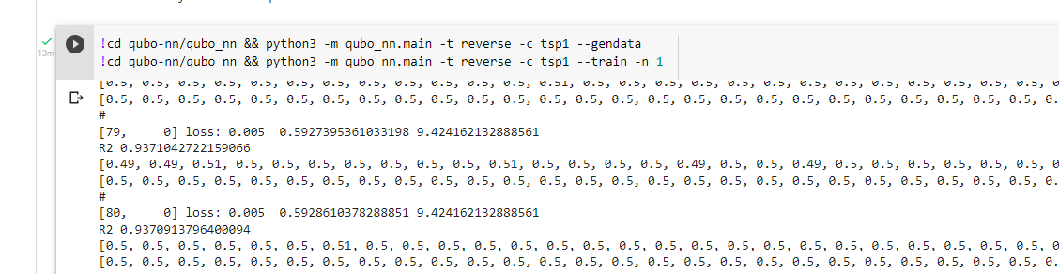

Zi’s Output time

D-Wave SDK

To install SDK: pip install dwave-ocean-sdk

Questions?

Do we use the same pipeline in the github or use Allen’s pipeline

Next Steps:

1. Develop this pipeline if we have to

2. Implement Qubo min/loss just the same way as the example